Covid 19 Application

* Describe your App idea

My app tracks user’s handwashing. Enabling users to follow the most effective guide for washing hands, whilst also encouraging the best hygiene practices. It will have a timer that ensures the user will wash their hands for the best health practice.

* Technical Details

The application will time user’s hand washing and track the course of washing by listening for a faucet running. The aim of the application is to ensure that younger kids wash their hands. However, the app can be used by anyone, not just children.

* Hardware Components

The application will use the device’s microphone, and the device’s speaker to audibly explain the steps while handwashing. The Microphone’s use is to ensure that the handwashing is taking place. It will also do it’s best to enable and disable the timer that would run within the app.

The speaker is to allow the user to hear the changes of step to step while handwashing, without requiring the user to use the screen, nor interact with the device with wet hands.

* Database Components

This application will use Firebase to store the records of user’s handwashing. It allows for the users to go back and view the handwashing details of previous days and compare it to how they’ve done up to now.

Firebase also allows us to enable new features down the line without building a whole new database structure. It also allows for users to access the database from a different device should they change to a new phone or tablet.

Using Firebase, ensuring user security and data integrity is of the upmost importance.

* Output

While the user is handwashing, alongside auditory queues to help, there will be images of the different stages and processes that the users should follow to wash their hands. Once they’re done, the app will display the stopwatch time to tell how long they spent washing their hands.

Ideally, users will wash their hands for times of around 30 seconds.

* Benefit of End Users

Users can keep their hands clean and reduce the spread of disease. It will promote good hygiene among the population, as well as giving a proper explanation to users who might not know how to properly wash their hands.

* Views

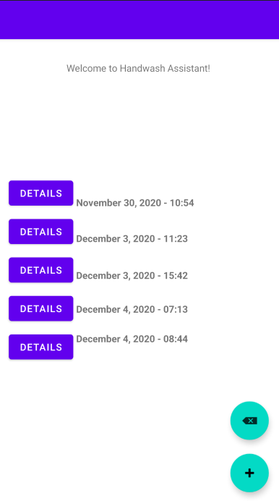

The image above represents the home screen. It has the options of starting a new handwash, deleting a previous one, and viewing the details of previous handwashes.

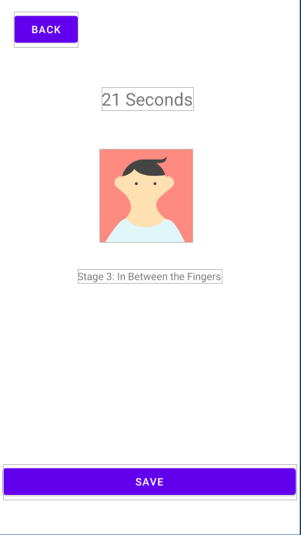

This image is of the handwashing screen – it will show you an image of the step that you’re on, a description of it, and how long you’ve washed your hands this instance. You then have the option to save it, after you finish, or to just go back to the previous screen.

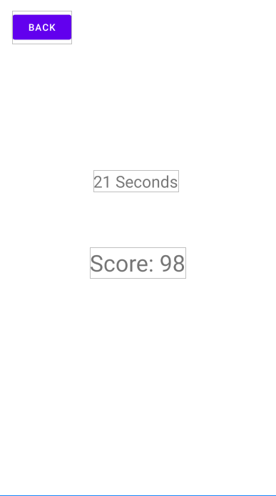

This image shows a previous handwashing score, with the time it took to wash your hands, and a score for the amount of time. If you washed your hands after 25 seconds, you’ll get a score of 100, but lose score for every 10 seconds over that you go, to prevent people from wasting water.